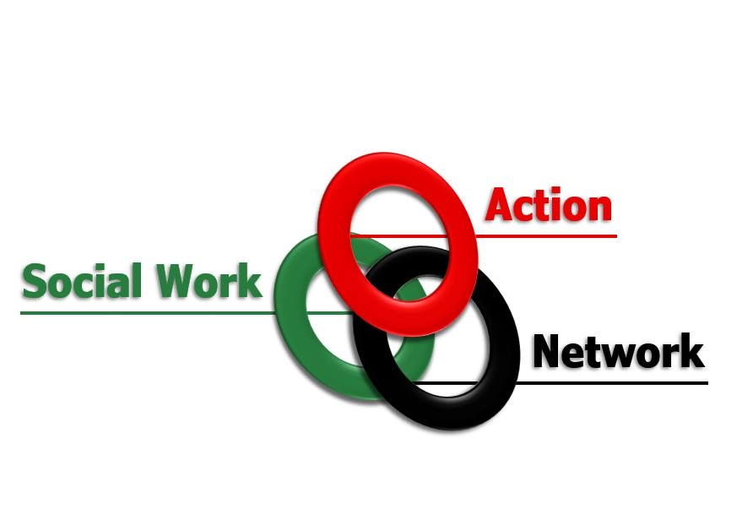
Vote of No Confidence in the Independent Children’s Services Review.
The government’s announcement that Josh MacAlister will chair an ‘independent’ review of children’s social care in England has provoked concern amongst the social work profession.
As social workers we are fully aware that the system is in crisis. At heart this is the result of years of cuts, austerity, privatisation and deregulation. We are in favour of a review of children’s services that will be, in the Government’s words, ‘radical’ but that means confronting the impact of years of privatisation, mismanagement and austerity. It requires the scope of the review is widened to assess the impact that poverty, austerity, racial and gender oppression and the privatisation of social services, including education, have had upon those with experience of care.
The present Government has a terrible record of cronyism with large contracts being offered to their friends and donors – as recently revealed by the New York Times. The appointment of MacAllister falls into this pattern. He is not a social worker and he is not independent.
MacAlister is the CEO of Frontline, a privatised provider of social work education. It has significant links with corporate partners and has been heavily funded by the global management company the Boston Consulting Group. He has previously published his ‘blueprint of child services’, in reality a blue print for privatisation. It is not appropriate that the review is being led by a privatisation ideologue
We demand that any review of children’s social care be led by a qualified social worker - someone who has the trust of frontline workers. And we demand that care-experienced people be included in the review leadership team.
The Social Work Action Network opposes Josh MacAlister’s appointment and calls for a vote of no confidence in the ‘independent’ review of children’s social care.

